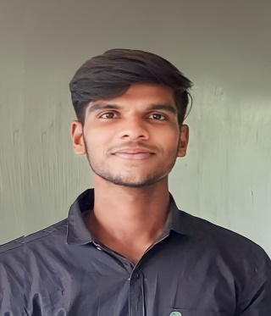NAME : THARUNKUMAR J DEPARTMENT: ELECTRICAL AND ELECTRICONICS ENGINEERING

**8015453665**





**tharunkumar.21ee@kct.ac.in**

# CAREER OBJECTIVE

**To pursue a successful, challenging & exciting career while being able to dispense my maximum potential to the benefit the organization and at the same time acquiring knowledge on road to success.**



# EDUCATION

**UG Dept: Electrical and Electronics Engineering**

## CLASS 12 : Government Higher

## Secondary School Vellaiyur

## CLASS 10 : Government Higher

## Secondary School Vellaiyur

Graduation: **2025**

CGPA**:7.76%**

Graduation:**2021**

Marks: **503.4/600**

Graduation:**2019**

Marks: **384/500**



# SKILLS

SOFTWARE SKILLS:

* C PROGRAMMING
* PYTHON PROGRAMMING
* HTML
* MATLAB
* AUTOCAD
* PLC

SOFT SKILLS:

* + LEADERSHIP
  + COMMUNICATION SKILLS
  + ADAPTIBILITY
  + ABILITY TO WORK UNDER PRESSURE
  + DECISION MARKING
  + TIME MANAGEMENT



# CERTIFICATION

# 

* QUIZ COMPITITION – DISTRICT LEVEL
* BATTERIS & ELECTRIC VEHICLES COURSE COMPLETED
* INTRODUCTION TO 3D MODULING COURSE COMPLETED
* CERTIFICATE OF ENERGY LITERACY
* WORKSHOP – E VEHICLE

# PROJECT

* WATER LEVEL ALARM (MINI PROJECT)
* HOSTEL MANAGEMENT (CREATE WEB PAGE)
* PLASTIC RECYCLING



# PERSONAL INTERESTS

* + - CREATING WEB PAGE
    - ART & DESIGN
    - EDITING PICTURES & VIDEOS
    - SONGS EDITOR (BACKGROUND REMOVER, ADD VOICE…)

# PERSONAL DETAILS

NAME : THARUNKUMAR J

D.O.B : 17/09/2004

FATHER’S NAME : JOTHI M

NATIONALITY : INDIAN

LANGUAGES

KNOWN : TELUGU, TAMIL, ENGLISH(SPEAK)

: TAMIL,ENGLISH (WRITE,READ)

HOBBIES : READING BOOKS, CREATE LYRICS FOR POEM,DRAWING,SINGING ,DANCING

EXERCISE,MEDITATION,

SPORTS : VOLLEYBALL,CHESS,CRICKET,CARROM & …….

ADDRESS : 71,EAST STREET,ANGANUR ,ULUNDURPET TALUK,KALLAKURICHI - 606107

**Declaration:**

I HEREBY DECLARE THE INFORMATION THAT THE INFORMATION FURNISHED ABOVE IS TRUE BEST OF MY KNOWLEDGE…

Signature

